AI STUDY BUDDY

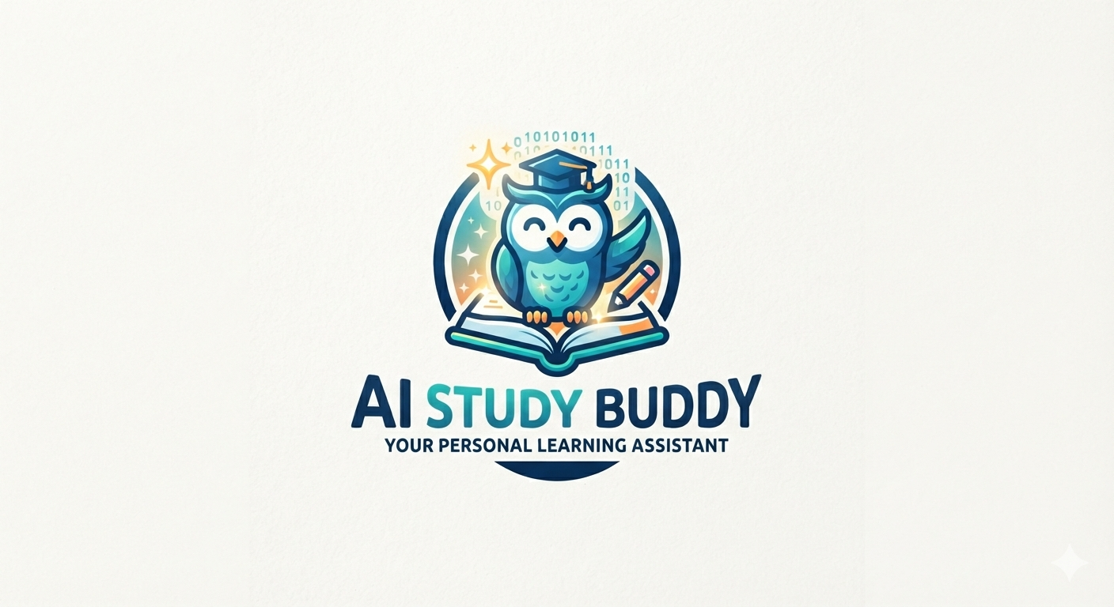

Project title : AI STUDY BUDDY
Team ID :
Team Leader:
Kavya Darsiny B: 24cskavyadarsiny040@gmail.com
Team members:
Jothi sree.H : 24csjothisree036@gmail.com
Karthika.R :24csKarthika039@gmail.com
Keerthana B:24cskeerthana041@gmail.com
PROJECT OVERVIEW

AI StudyBuddy is an AI-based educational assistant designed to help students study more effectively. It provides personalized learning support, answers students’ questions, summarizes study materials, and helps them prepare for exams.
KEY OBJECTIVES:
Personalized Learning – Provide study support based on each student’s learning needs.
Instant Doubt Resolution – Help students get quick answers and explanations to their questions.
Smart Study Materials – Generate summaries, notes, and important points from study content.
Exam Preparation – Help students practice questions and prepare effectively for exams.
Progress Tracking – Monitor learning progress and encourage students to improve their performance.
TARGET USERS:
School Students – For learning subjects and clearing doubts.
College Students – For notes, assignments, and exam preparation.
Competitive Exam Students – For practice questions and revision.
Teachers – To create study materials and support students.
Self-Learners – For learning new topics independently.

KNOWLEDGE REQUIREMENTS
JavaScript ES6+ syntax and concepts
• Node.js and Express.js for RESTful API development
• MongoDB and Mongoose ODM
• JWT authentication and bcrypt password hashing
• Git version control workflow

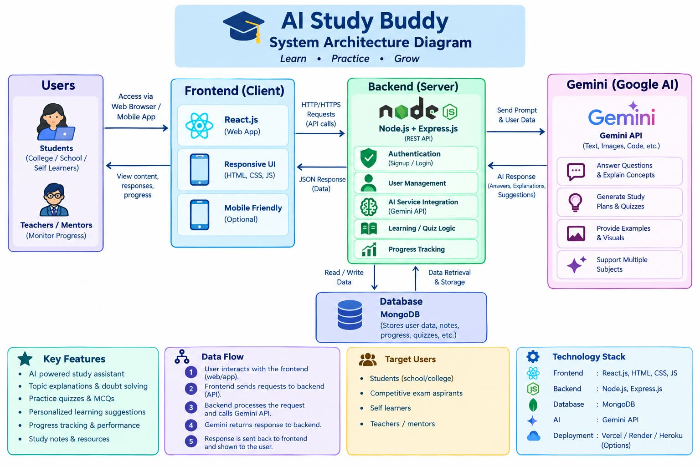
Node.js + Express Backend
* RESTful API architecture
* JWT authentication middleware
* MVC pattern (Models, Controllers, Routes)
* Input validation and error handling

MongoDB Database
* Document-based NoSQL storage
* Mongoose ODM for schema modeling
* Two collections: Users and Contacts
* Indexed fields for optimized queries

TECHNICAL ARCHITECTURE
Backend Architecture (Node.js + Express)
• Controllers: Business logic for authentication and CRUD operations
• Models: Mongoose schemas defining data structure
• Routes: API endpoint definitions with HTTP methods
• Middleware: JWT verification, error handling, validation
• Configuration: Database connection and environment variables
Database Architecture (MongoDB)
• Users Collection: _id, name, email, password (hashed), timestamps
• Contacts Collection: _id, userId (FK), name, email, phone, notes, tags[], timestamps
• Relationships: Many-to-One (Contacts → User)
• Indexes: email (unique), userId, name, tags (for search)

ER DIAGRAM:

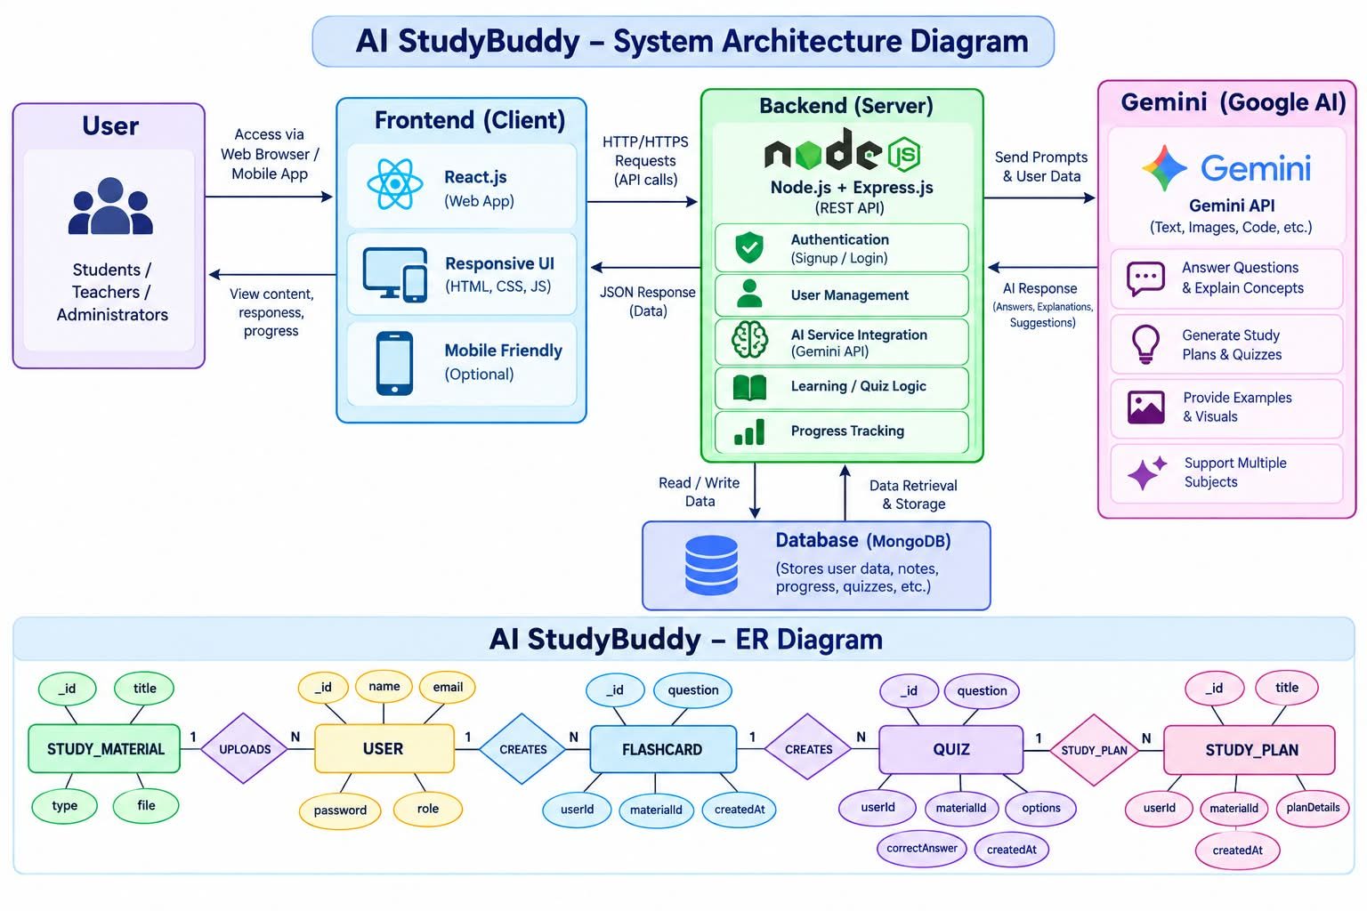
ROLES AND RESPONSIBILITY
Student
Students are the primary users of the system. They can register, log in securely, upload study materials, and utilize AI-powered features such as summary generation, flashcard creation, quiz generation, and personalized study plans. Students can also view and manage their previously generated learning resources.
Administrator
Administrators manage the overall system and ensure its smooth operation. They monitor registered users, manage user accounts, oversee application usage, maintain system integrity, and ensure that AI-powered services function correctly. Administrators also have permission to perform system-level management tasks and resolve user-related issues.
User Flow
The AI StudyBuddy application begins with the user registering or logging into the system. After successful JWT-based authentication, the user is redirected to the dashboard, where they can upload study materials and access AI-powered features. Based on the uploaded content, the system generates summaries, flashcards, quizzes, or personalized study plans using the Google Gemini API. All generated resources are displayed to the user and can be saved for future reference. Users can also manage their profile and view their previously generated learning resources through the dashboard.
USER FLOW:
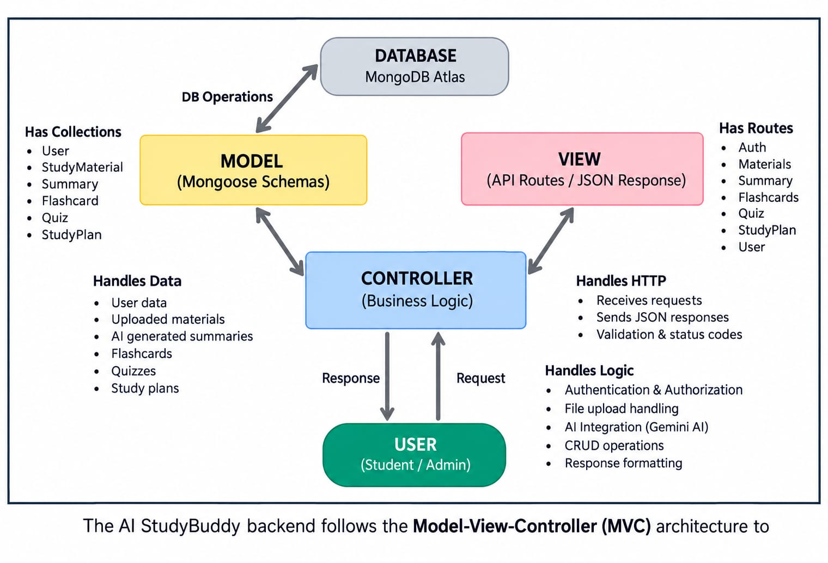
PROJECT SETUP AND CONFIGURATION:
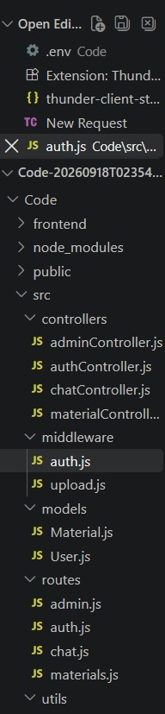

Project Setup

1. Install required tools and software:
• Node.js.
• MongoDB.
2. Create project folders and files:
• Server folders.
3. Install Packages:
Backend npm Packages
• Express.
• Mongoose.
• Cors.

BACKEND DEVELOPMENT:
T he AI StudyBuddy backend is developed using Node.js, Express.js, and MongoDB, following a modular architecture. The application separates routing, controllers, middleware, models, and utility modules to improve code maintainability and scalability. The backend exposes secure REST APIs for authentication, study material management, AI-powered content generation, and administrative operations.

CORE SYSTEM SCRIPT IMPLEMENTATIONS:
- Application Entry Point (index.js)
The index.js file serves as the main entry point of the application. It initializes the Express server, loads environment variables, configures middleware, establishes the MongoDB connection, registers API routes, and starts the server after a successful database connection

The core system of AI Study Buddy is implemented using Node.js, Express.js, and Google Gemini AI. The backend receives user requests and study materials, processes the data, and sends suitable prompts to Gemini AI. Gemini generates summaries, quizzes, flashcards, study plans, and answers to students’ questions. Authentication middleware protects user accounts, while file-upload middleware validates and stores study materials. The generated results are then returned to the frontend and displayed through the student dashboard.
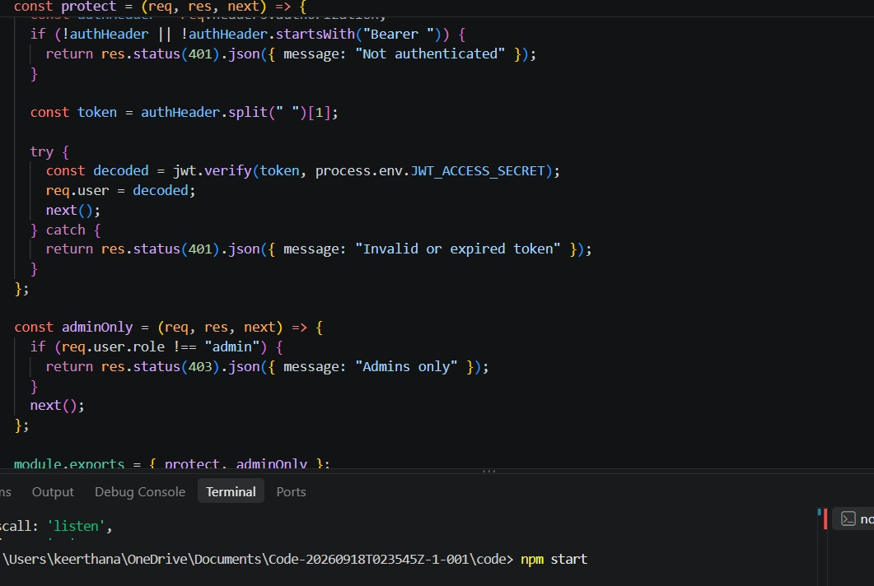

2.DATABASE CONNECTION (src/utils/db.js)
This module establishes a connection between the application and MongoDB using Mongoose. It ensures that the backend communicates with the database before processing any client requests.

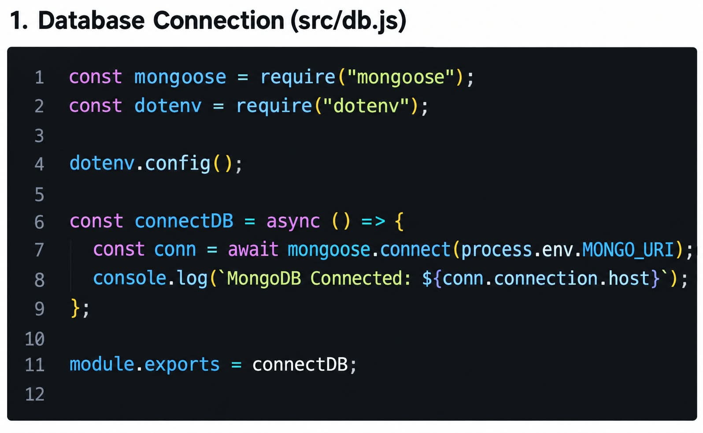
3. AUTHENTICATION MIDDLEWARE (src/middleware/auth.js)
The authentication middleware verifies JWT access tokens for protected routes. It authenticates users before granting access to secured APIs and includes role-based authorization to restrict administrative operations.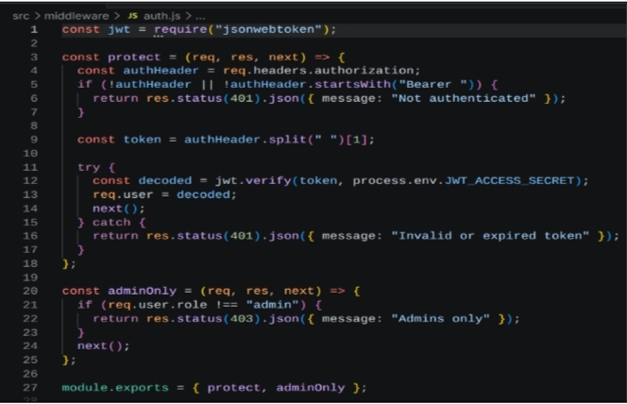

4. AI INTEGRATION (src/utils/gemini.js)
This utility integrates the backend with the Google Gemini 2.5 Flash API. It sends prompts to the AI model and returns generated responses for summaries, flashcards, quizzes, and
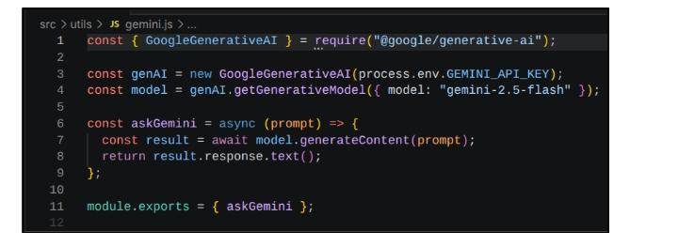
5.FILE UPLOAD MIDDLEWARE (src/middleware/upload.js)
The upload middleware handles study material uploads and validates incoming files before they are processed by the backend
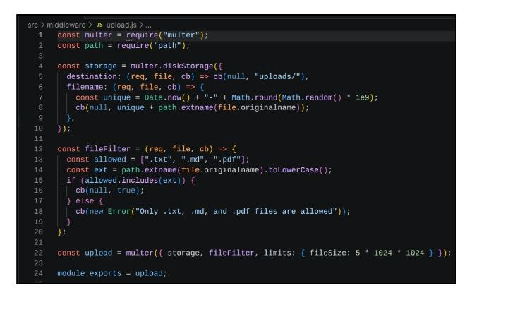
PROJECT EXECUTION:
The AI StudyBuddy backend can be executed locally using Node.js. Before running the application, ensure that MongoDB is running and the required environment variables are configured correctly. The backend exposes REST APIs that can be tested using Postman or Thunder Client.
Running the Backend Server
Install all required dependencies:
npm install
Start the development server:
npm start
After successful execution, the server connects to MongoDB and starts listening for incoming API requests.
API Testing
The backend APIs can be tested using Postman.
1. User Registration
Registers a new user by accepting the required details and securely storing the encrypted password in the MongoDB database.
Endpoint:
POST /api/auth/register
2.User Login
Authenticates the registered user and generates a JWT access token for accessing protected APIs.
Endpoint:
POST /api/auth/login
3. Upload Study Material
Allows authenticated users to upload study material that will be used as input for AI-powered content generation.
Endpoint:
POST /api/material/upload
4. Generate AI Summary
Sends the uploaded study material to the Google Gemini API and generates a concise summary.
Endpoint:
POST /api/materials/:id/summarize
5. Generate AI Flashcards
Creates AI-generated flashcards from the uploaded study material for effective revision.
Endpoint:
POST /api/ai/flashcards
6.Generate AI Quiz
Generates multiple-choice questions from the uploaded study material to help users assess their understanding.
Endpoint:
POST /api/ai/quiz
7. Generate AI Study Plan
Creates a personalized study schedule based on the user's learning goals and available study time.
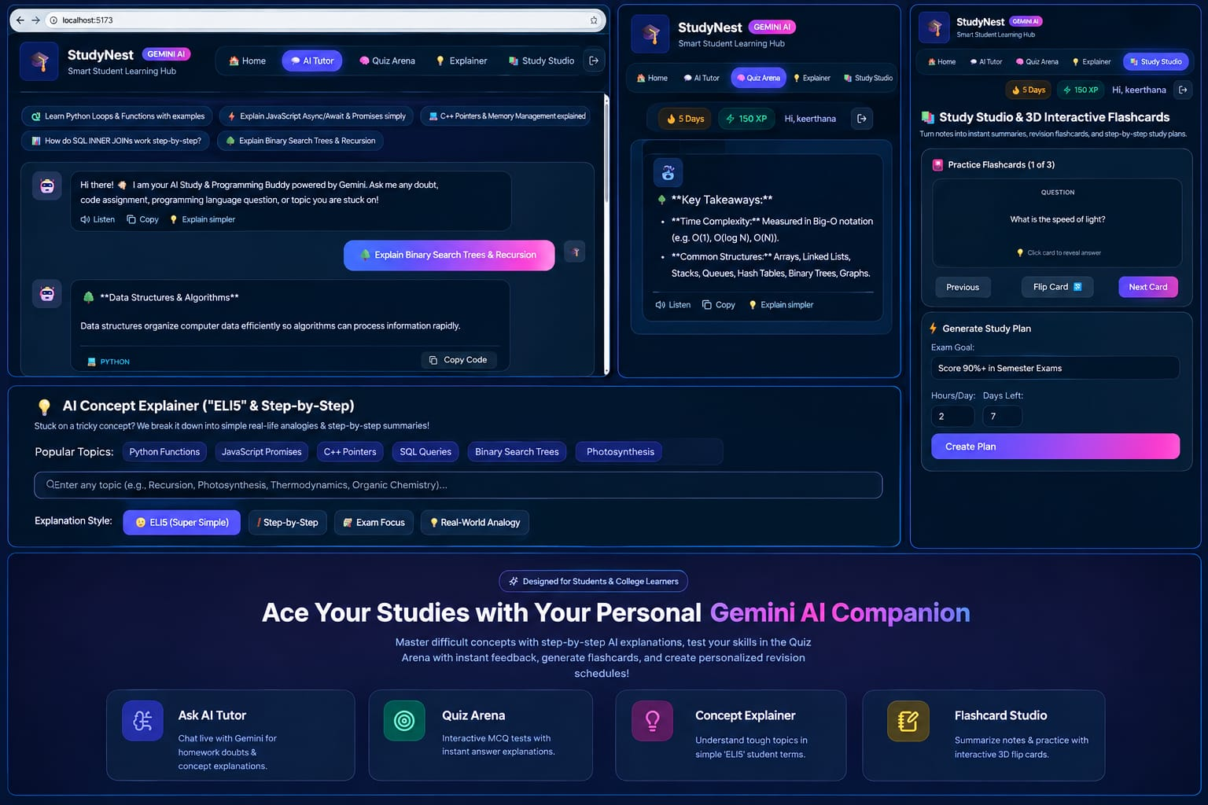
ENDPOINT:
POST/api/ai/study-plan
CONCLUSION:
AI Study Buddy is a smart and user-friendly learning assistant that makes studying easier and more effective. It uses Gemini AI to generate summaries, quizzes, flashcards, and personalized study plans from study materials. The chatbot also helps students clear their doubts and understand difficult topics. Overall, the project helps students save time, organize their studies, and improve their learning experience through AI technology.

